DESIGN SPEC

Team Casting Puget Sound

Annie Bequette (Dev), Emily Dooley (Prod), Jacob Strozyk (Dev),

Sebastian Pasion (PM), Spencer Pudists (Dev)

# 

# **PROBLEM**

Puget Sound marine populations have long been in decline or at best hovering at dangerous levels. One of the factors that adversely affects these fish/crustacean populations is the overfishing of vulnerable species by recreational fishers.

# **SOLUTION SUMMARY**

This web application will provide fishermen with accurate recommendations of which regions are best for abundant and sustainable fishing.

# **SITE LAYOUT**

Our site will have five pages: a home page, a map of marine area/species information (stretch goal), an explore page where users can find information about marine areas/species, a page where users can get involved in supporting sustainable fishing, and a page about the problem and our mission.

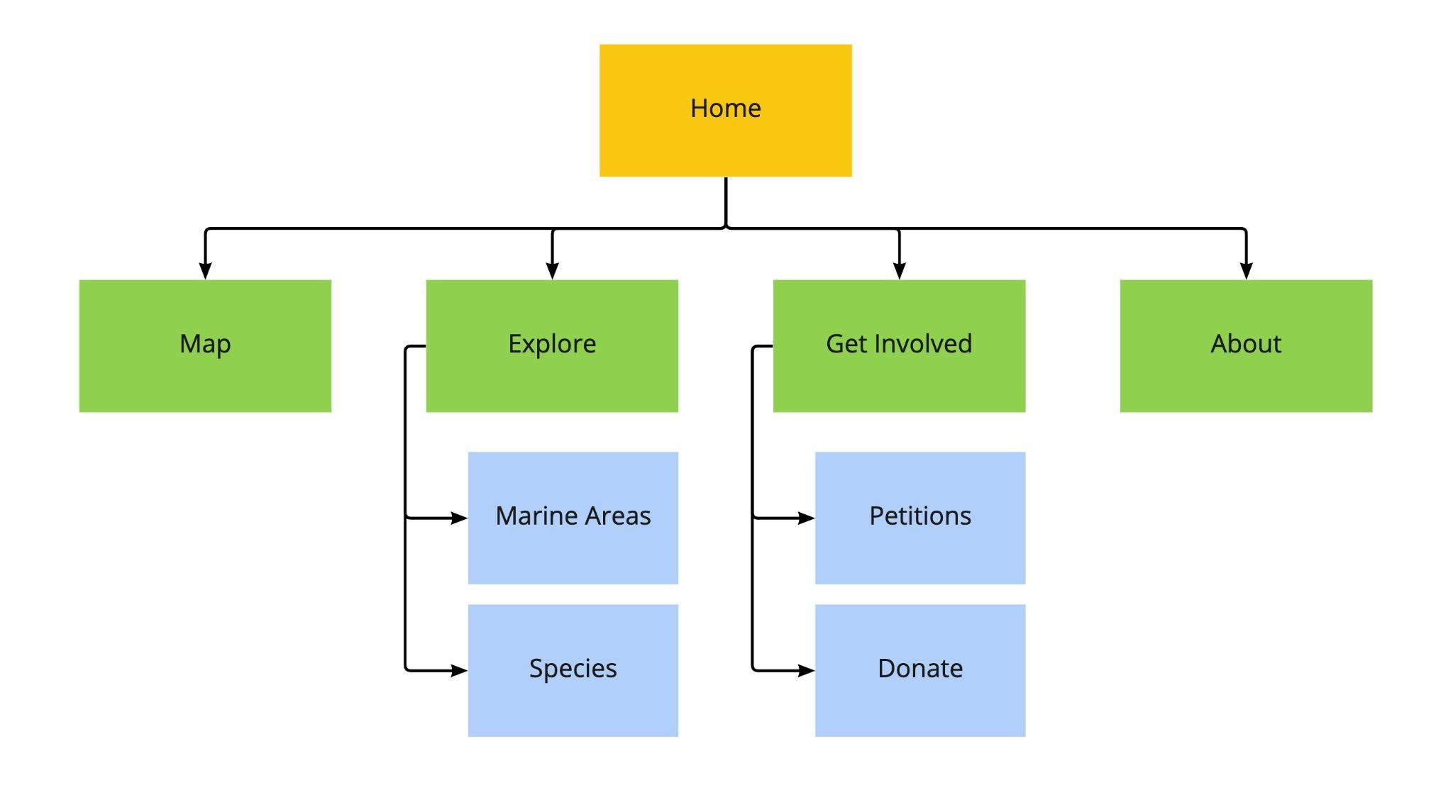

# **DESIGN**

## Home

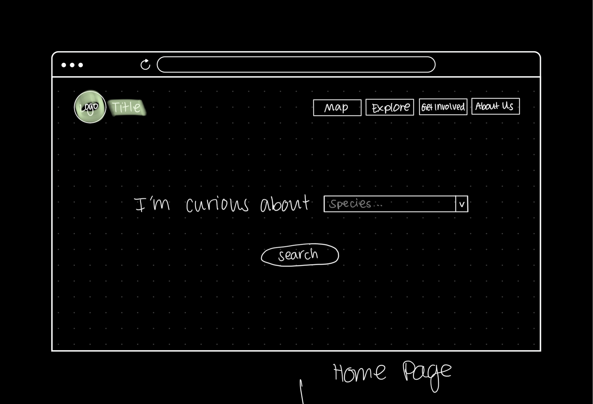

The home page prompts the user to select the species they are curious about from a drop down menu. Users complete this search by pressing the ‘Search’ button. They will be redirected to the ‘Map’ page, which returns a density map showing where in the Puget Sound the specific species is most frequently found. The home page can be accessed at any point by clicking on the logo or title in the top left corner of the page. Users can also interact with the navigation bar at any point on this page.

## Map (Stretch Goal)

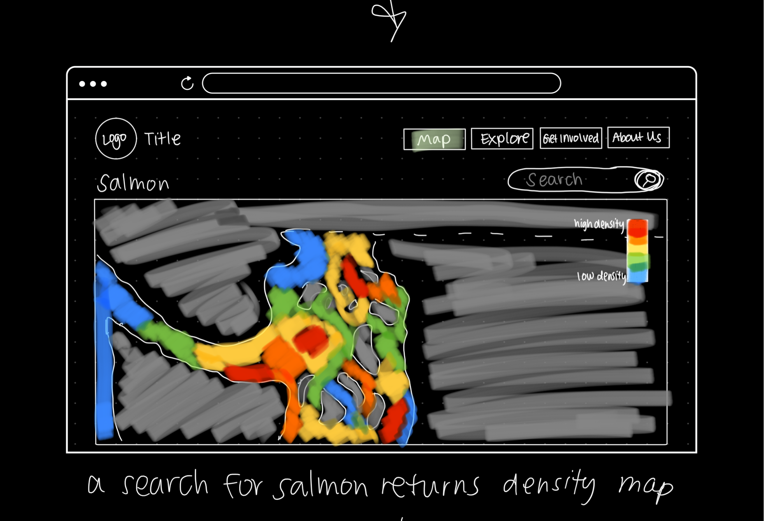

The ‘Map’ page displays a density map of the Puget Sound waters depending on the species that was selected by the user. This page can be accessed by either completing the search on the home page or clicking on the respective button in the navigation bar. When entering from a search on the home page, users will automatically see the map for the specific species they searched. If the user is to enter this page through the navigation bar, the map will show a default state until the user searches for a species. A search can be completed in the search bar above the top right corner of the map. The search bar will generate a drop down menu similar to the one on the home page. Users can also interact with the navigation bar at any point on this page. This page is a stretch goal.

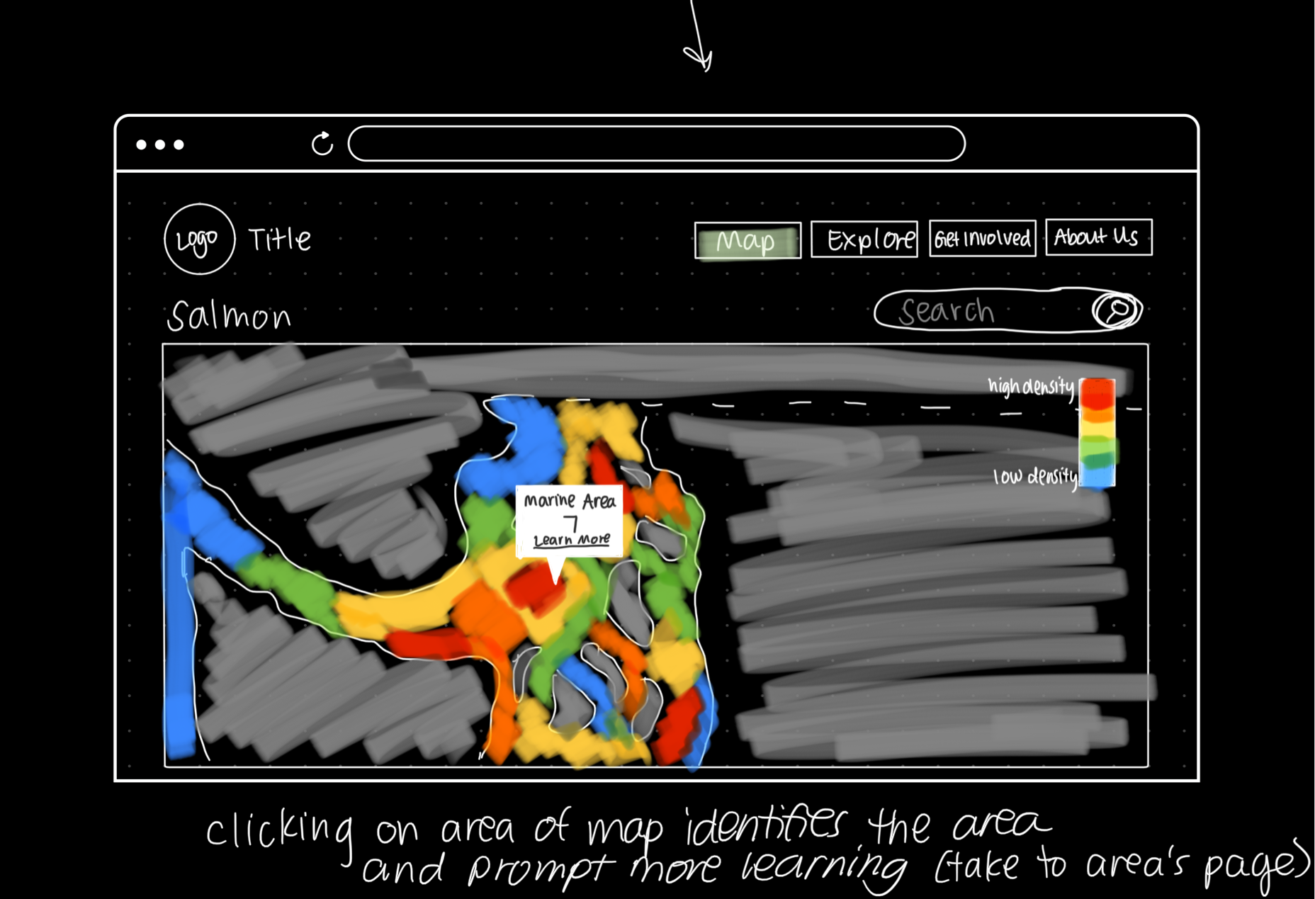

The map is clickable and will provide users with the name of the marine area they select through a pop-up. There will also be a hyperlink within the pop-up, titled ‘Learn More’, prompting users to read more about the marine area. If this link is clicked, users will be redirected to the page displaying information about the selected marine layer. To exit the pop-up, users can click anywhere on the map. Clicking on another area in the Puget Sound will prompt a new pop-up for the marine area, while clicking on the land will close the pop-up entirely. Users can also interact with the navigation bar at any point on this page. This page is a stretch goal.

## Explore

## 

The ‘Explore’ page will show the two categories users can further explore, ‘Marine Areas’ and ‘Species’. Users will interact with this page by clicking on either of the categories, which will redirect them to the corresponding subpage. Users can also interact with the navigation bar at any point on this page.

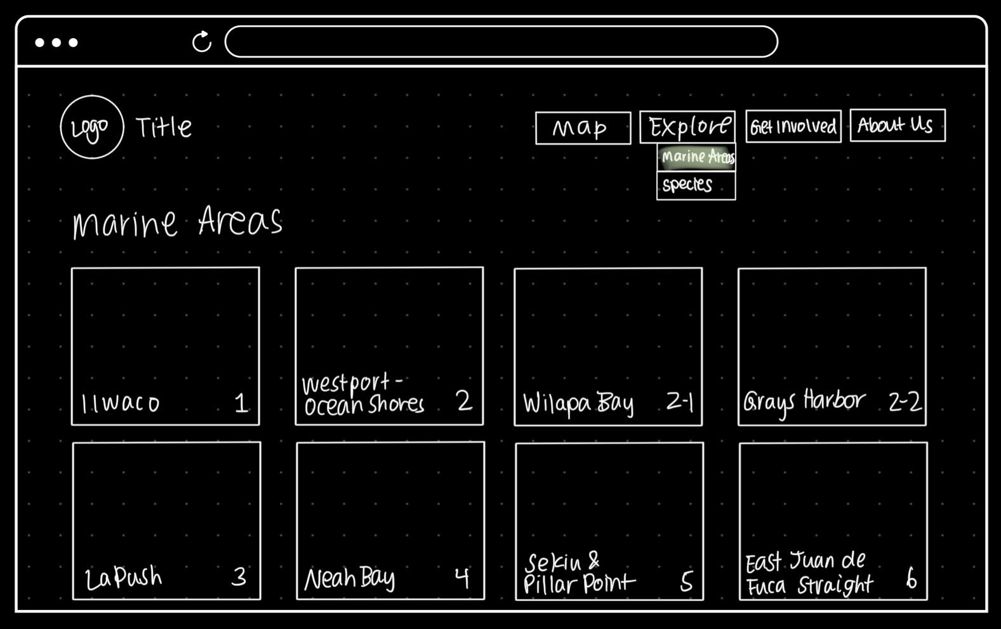

This page displays each marine area in the Puget Sound. This page is scrollable and will feature a card for every marine area. Each card is clickable and will redirect the user to a new page. This subpage can also be accessed by hovering over the ‘Explore’ button in the navigation bar. Users can also interact with the navigation bar at any point on this page.

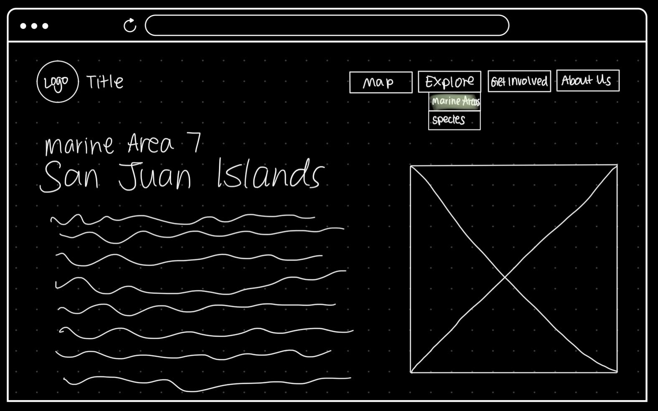

This page displays the specific information for the marine area the user selected. A photo of the area’s location within the Puget Sound will be shown next to the written information about the area. This may be a scrollable page depending on the amount of information we include. Users can also interact with the navigation bar at any point on this page.

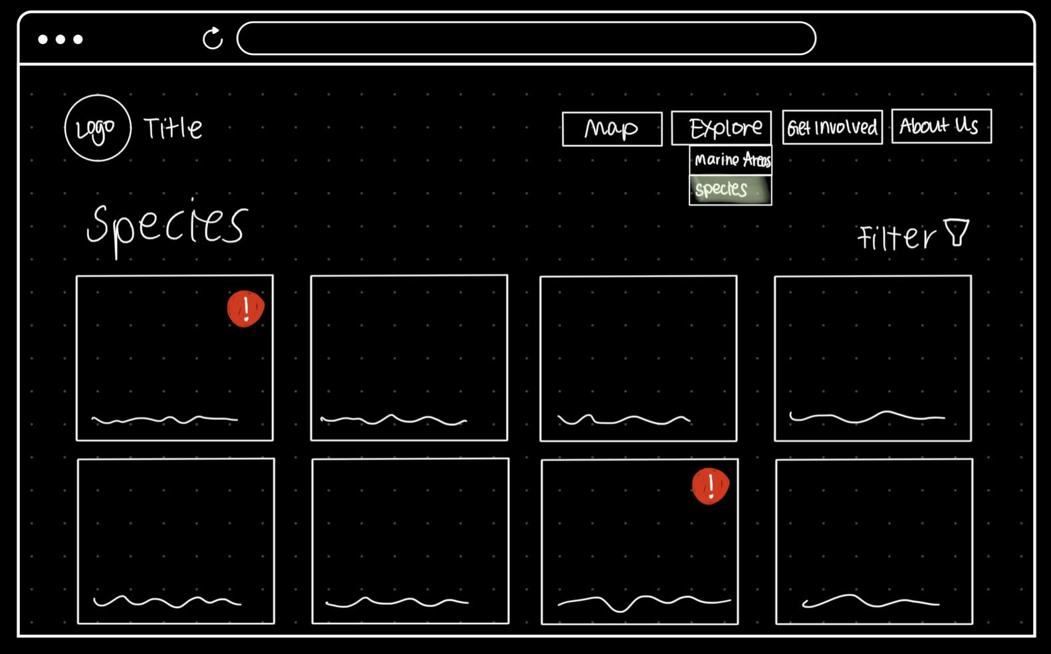

This page displays common species found in the Puget Sound. This page is scrollable and will feature a card for each species we decide to feature. Each card is clickable and will redirect the user to a new page. A filter will be available at the top right corner above the cards where users can filter the cards by marine area, A-Z (default state), or at-risk species. Users can select and apply a filter by clicking the icon and confirming their selection. To remove the filter, they would click the same icon, deselect their choice, and confirm. This subpage can also be accessed by hovering over the ‘Explore’ button in the navigation bar. Users can also interact with the navigation bar at any point on this page.

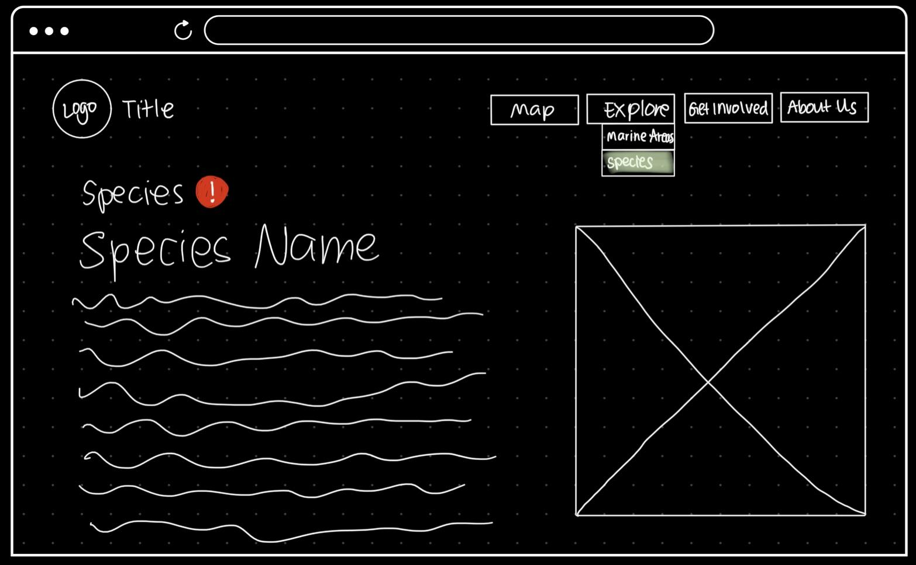

This page displays the specific information for the species the user selected. A photo of the species will be shown next to the written information about it. This may be a scrollable page depending on the amount of information we include. Users can also interact with the navigation bar at any point on this page.

## Get Involved

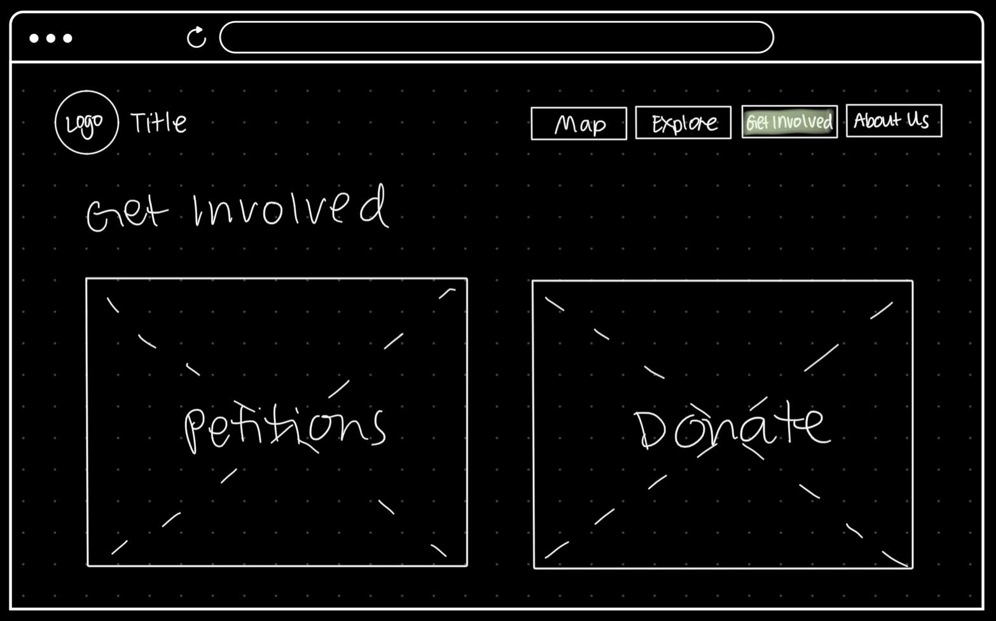

The ‘Get Involved’ page will show the two categories users can further explore, ‘Petitions’ and ‘Donate’. Users will interact with this page by clicking on either of the categories, which will redirect them to the corresponding subpage. Users can also interact with the navigation bar at any point on this page.

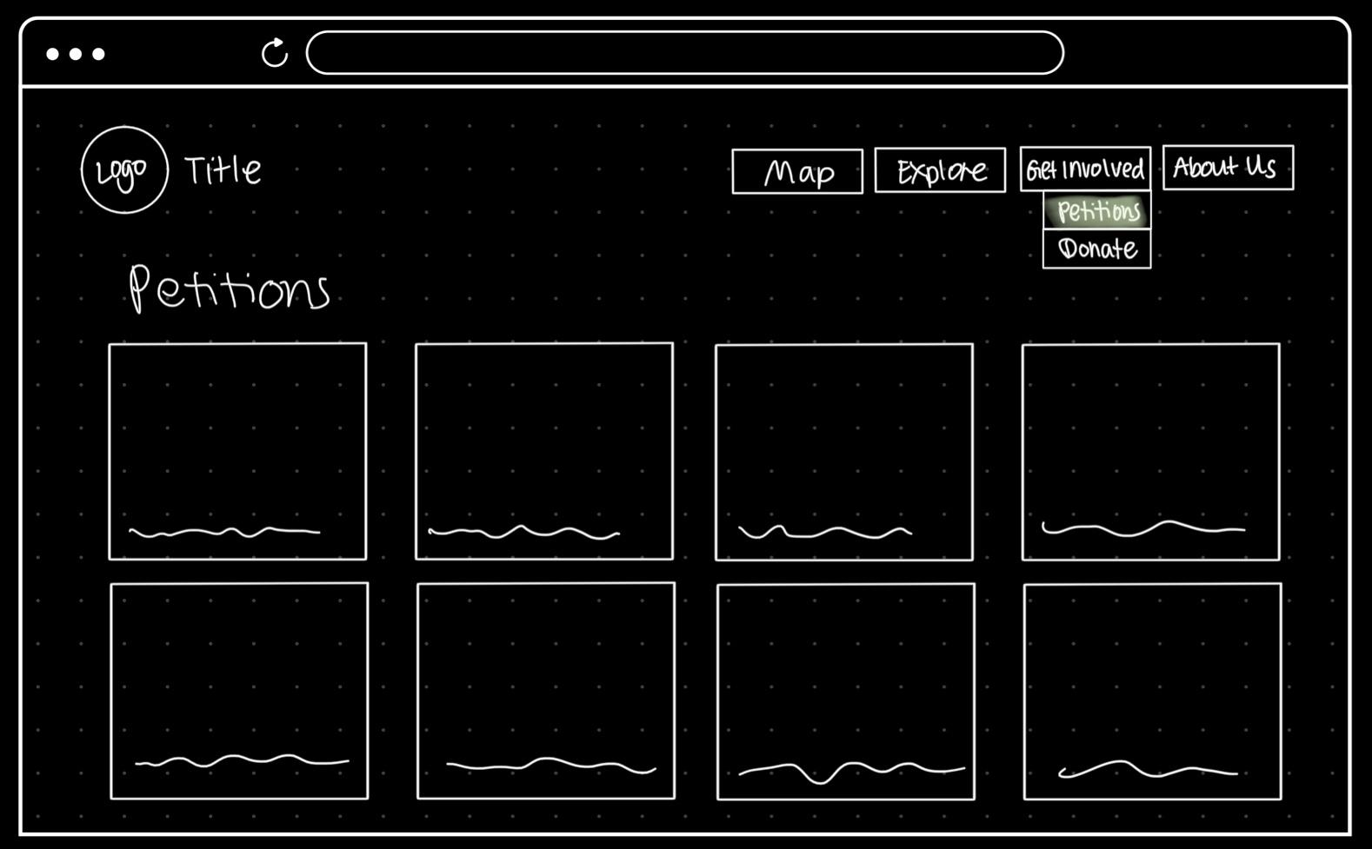

This page displays petitions relating to fishing and sustainability in the Puget Sound area. This page is scrollable and will feature a card for each petition we decide to feature. Each card is clickable and will redirect the user to a new page. This subpage can also be accessed by hovering over the ‘Get Involved’ button in the navigation bar. Users can also interact with the navigation bar at any point on this page.

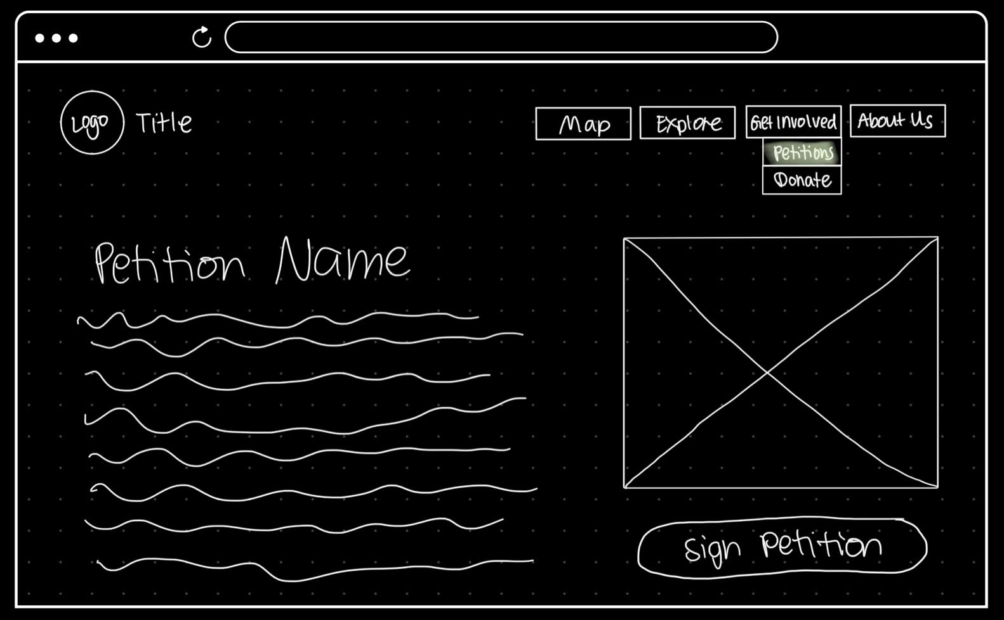

This page displays the specific information for the petition the user selected. Some sort of related photo (the organization’s logo or team, a stock photo related to the petition, etc.) will be shown next to the written information about it. This may be a scrollable page depending on the amount of information we include. Users can also interact with the navigation bar at any point on this page.

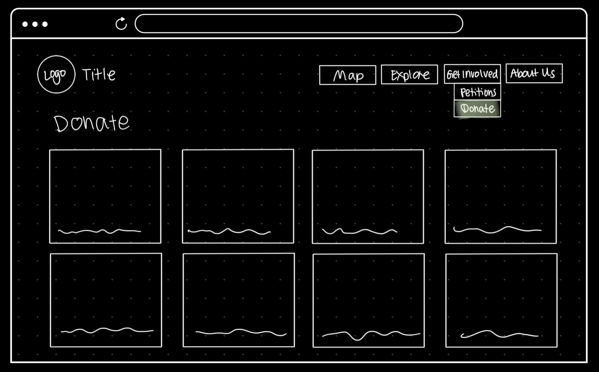

This page displays donation funds relating to fishing and sustainability in the Puget Sound area. This page is scrollable and will feature a card for each fund we decide to feature. Each card is clickable and will redirect the user to a new page. This subpage can also be accessed by hovering over the ‘Get Involved’ button in the navigation bar. Users can also interact with the navigation bar at any point on this page.

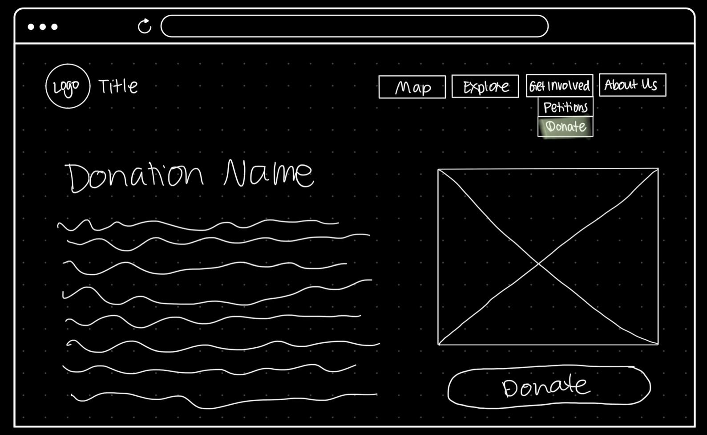

This page displays the specific information for the donation fund the user selected. Some sort of related photo (the organization’s logo or team, a stock photo related to the donation’s cause, etc.) will be shown next to the written information about it. This may be a scrollable page depending on the amount of information we include. Users can also interact with the navigation bar at any point on this page.

## About

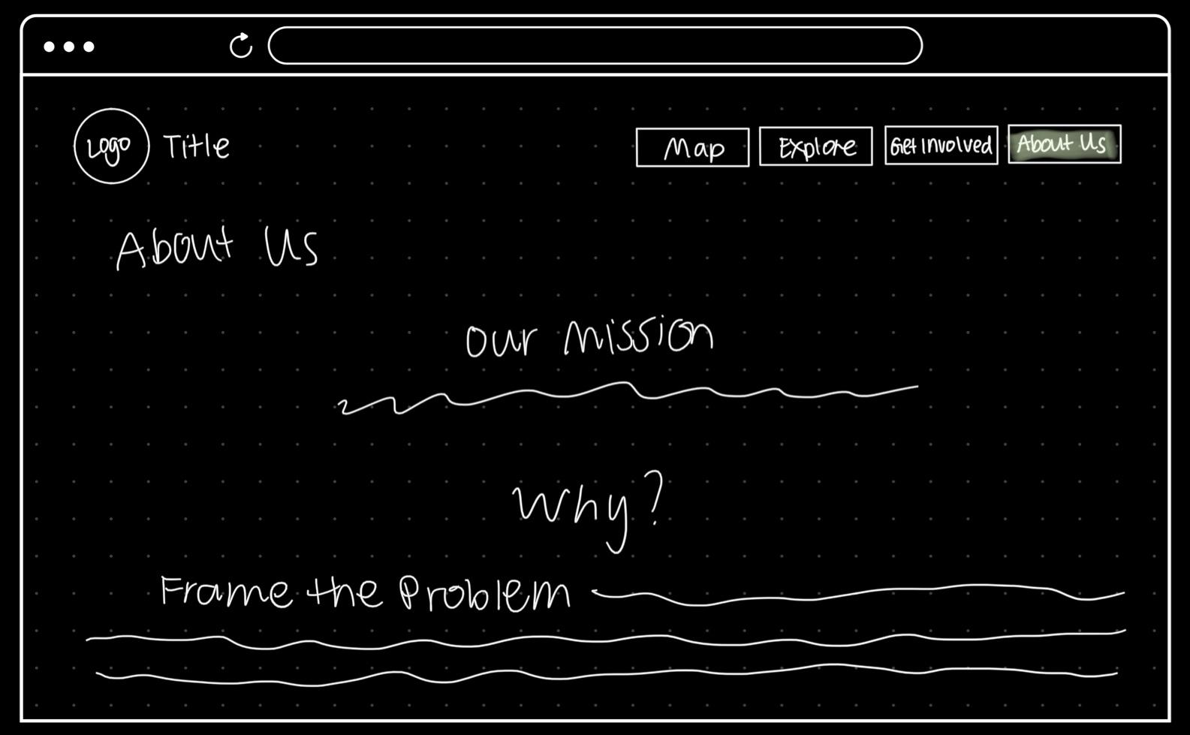

This page will feature information about our team’s mission and why we created this site. We will frame the problem using information we gathered when creating our problem statement. This may be a scrollable page depending on the amount of information we include. Users can also interact with the navigation bar at any point on this page.